Your Visit to Westminster Abbey

Westminster Abbey is a big church in London.   
Everyone is welcome here.

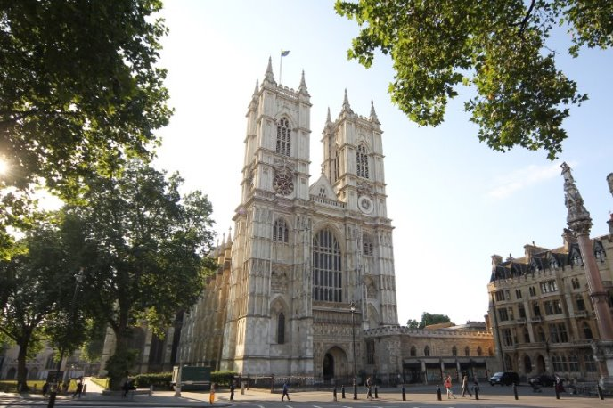

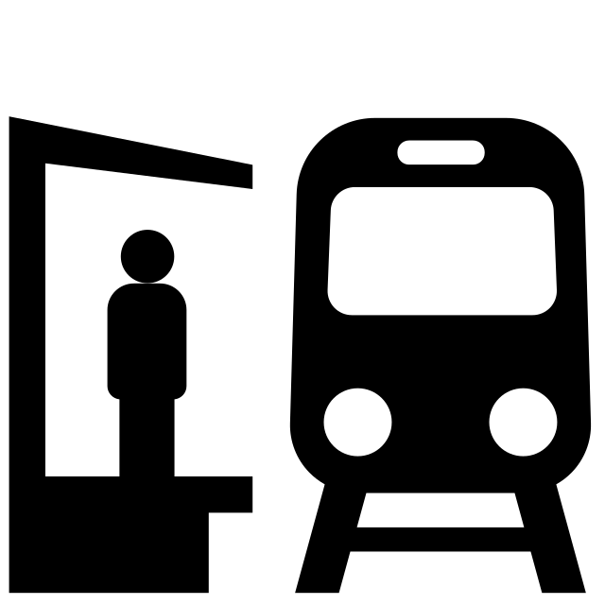You might travel to Westminster Abbey on a bus, a train, a coach or by walking.



The area around Westminster Abbey can be very loud and busy with people and cars.

When you arrive you will walk around this barrier and through the 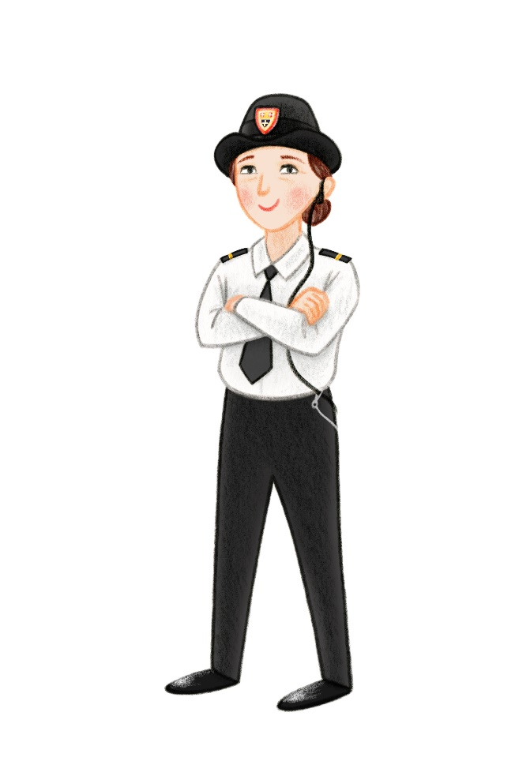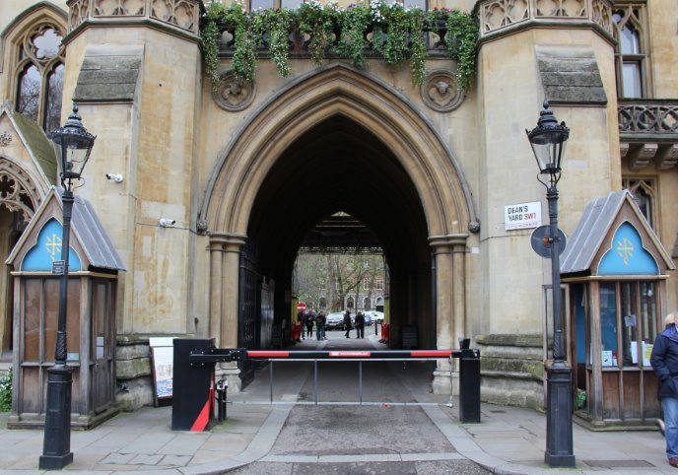archway.

You might meet one of our security team, who we call Beadles. They are very nice and can help you find your way.​

​

You will enter through this entrance.

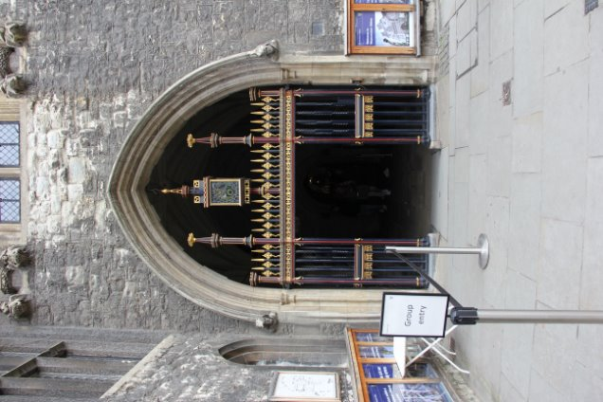You might have to queue outside.

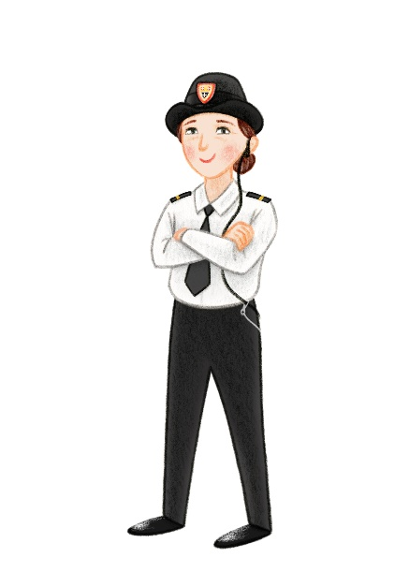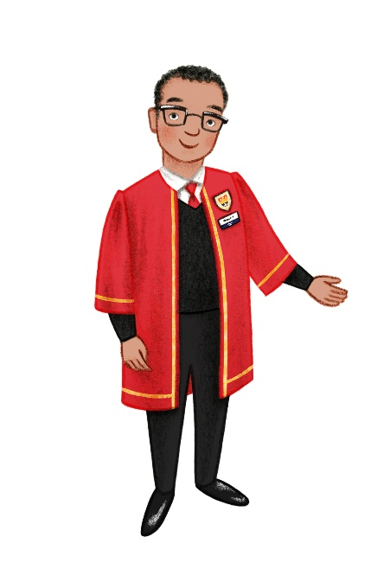You will be given a wrist band to wear during your visit.

There will be members of Abbey staff here to help you.

You will enter the Abbey through the cloisters. This area can be dark.

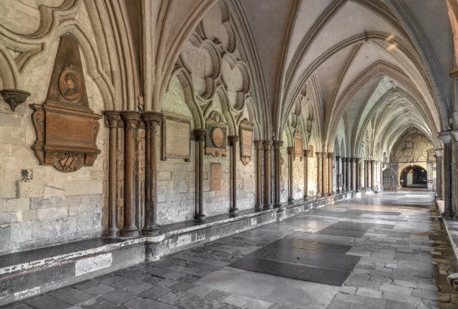

There are toilets in the cloisters. You might use these at the start of your visit. There is an accessible toilet here.

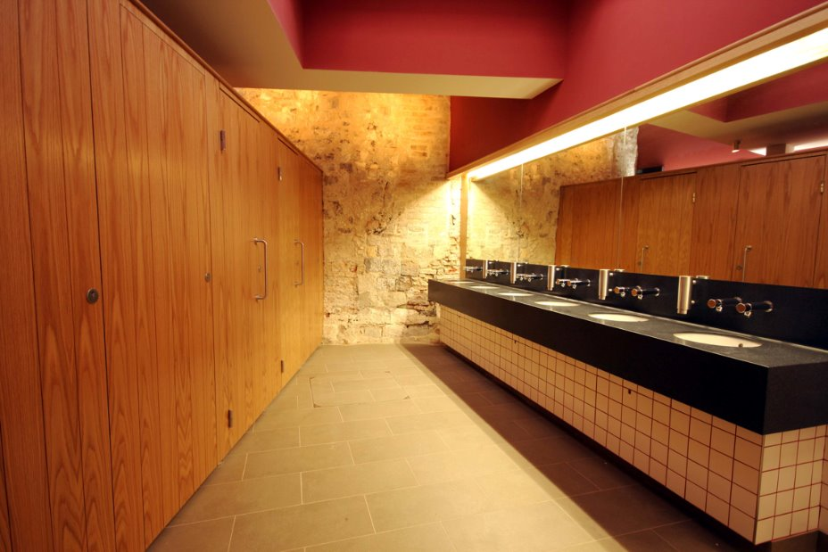

Inside the Abbey it might be busy with lots of visitors and people 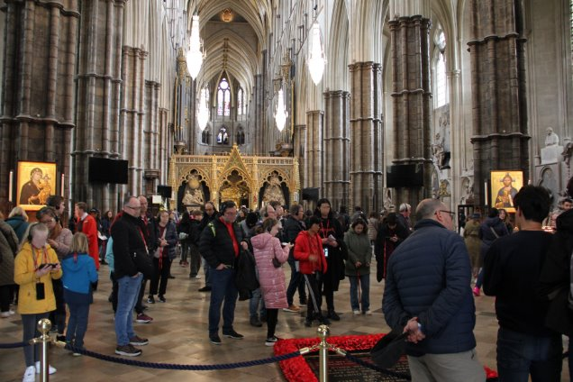who have come to pray.

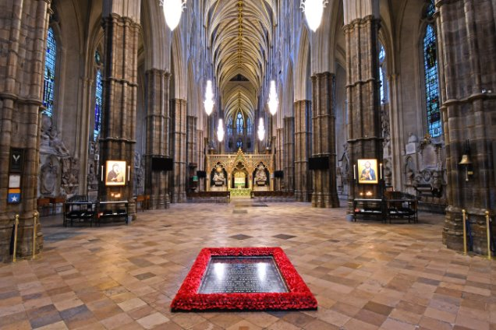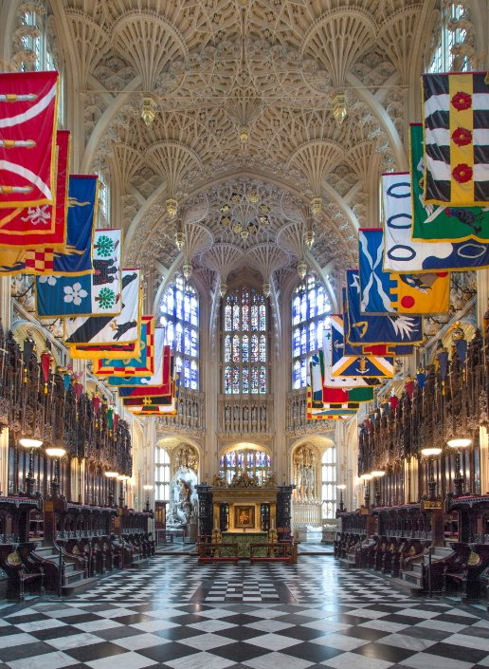

The Abbey has very high ceilings.

This can make sounds echo.

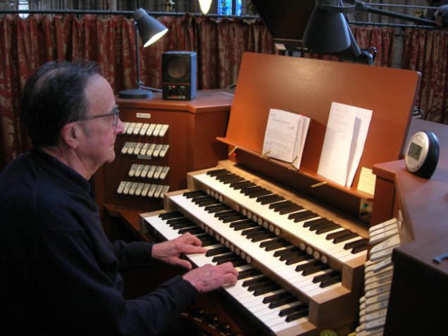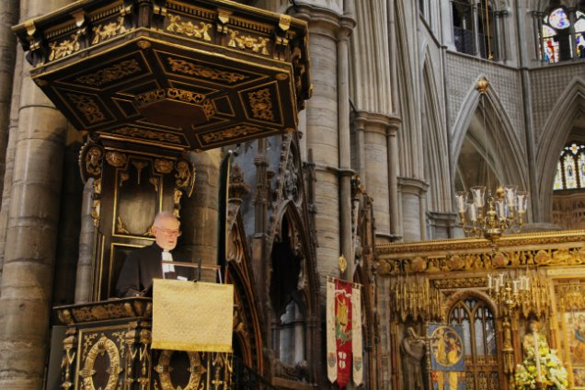Whilst at the Abbey you might hear:

People talking

People saying prayers

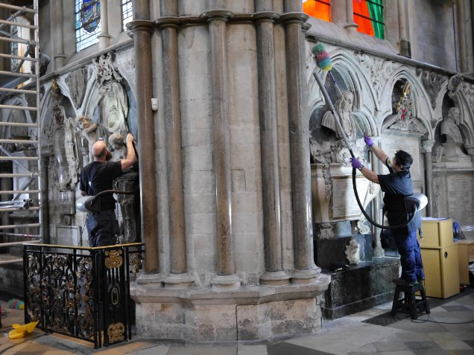Bells ringing

Music playing

People cleaning

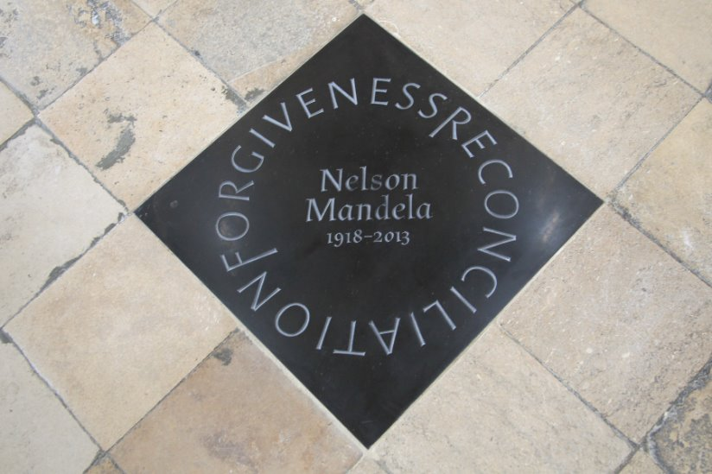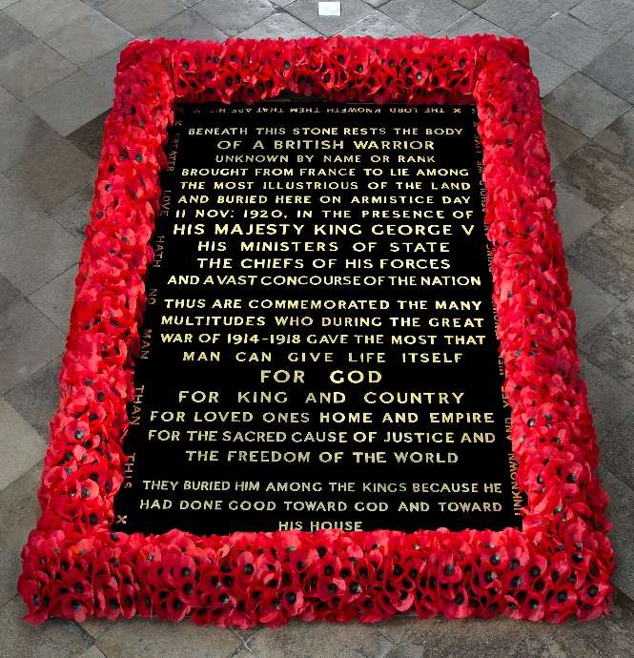 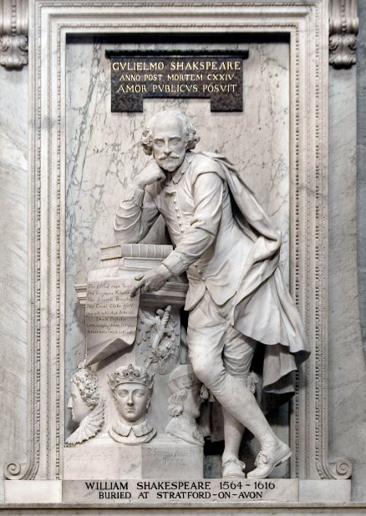Westminster Abbey is a place of burial and remembrance. There are graves, memorials and statues for people all over the Abbey.

You’re allowed to walk over the graves and memorials on the floor, except for the one surrounded by poppies.

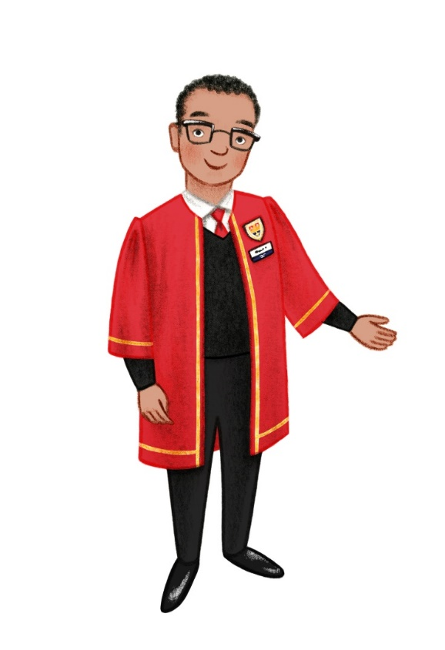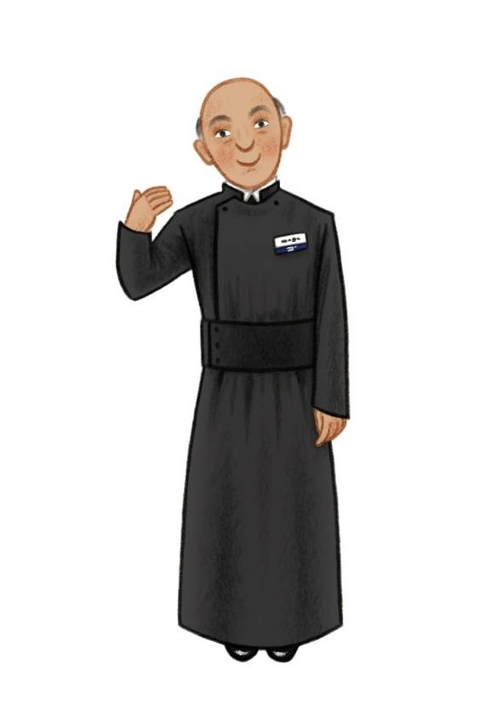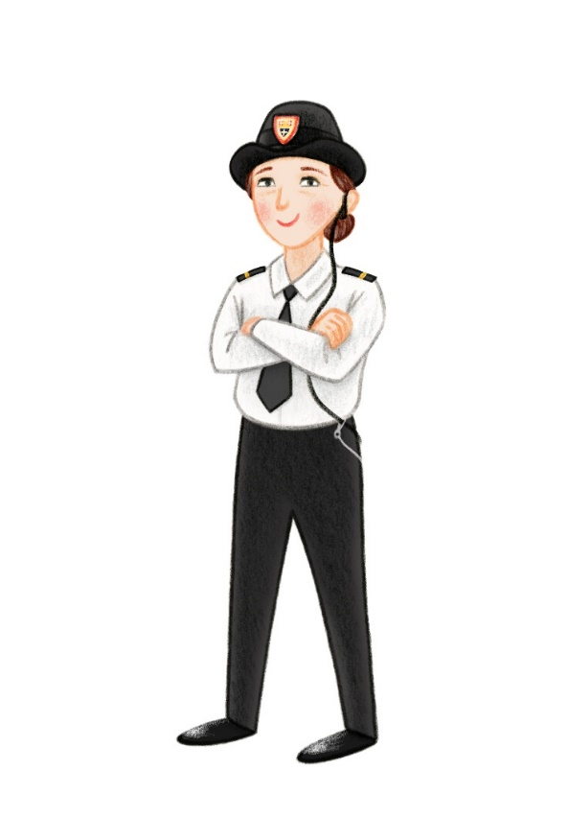If you need help during your visit, you could talk to

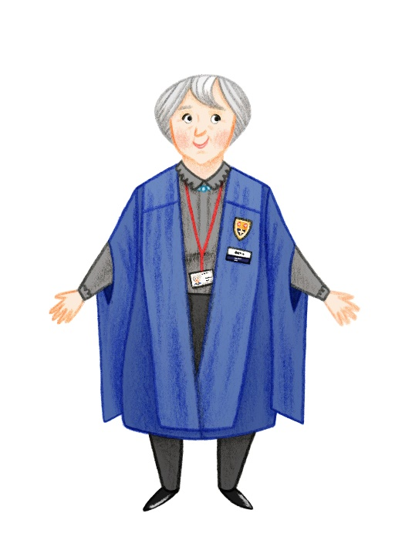

Beadles (Security)

Chaplains

Marshals

Volunteers

Vergers

Welcome Team

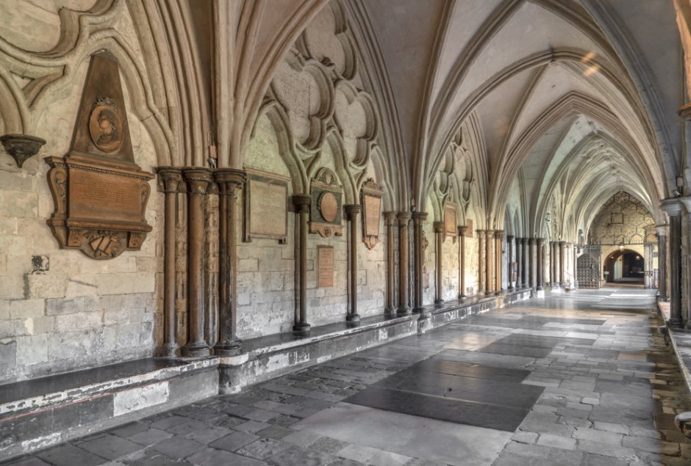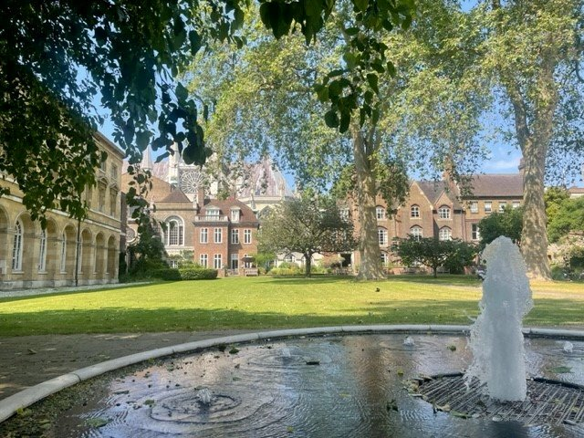If you need a time out or a quiet space during your visit, you could go to

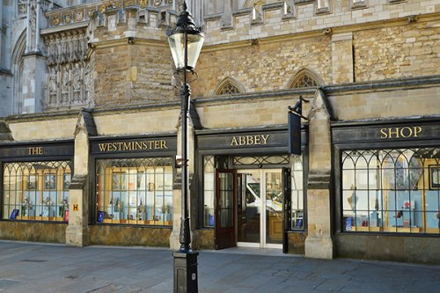t the end of your visit you might have lunch in the cloisters or the garden. Or you might visit the shop.

The garden

The cloisters

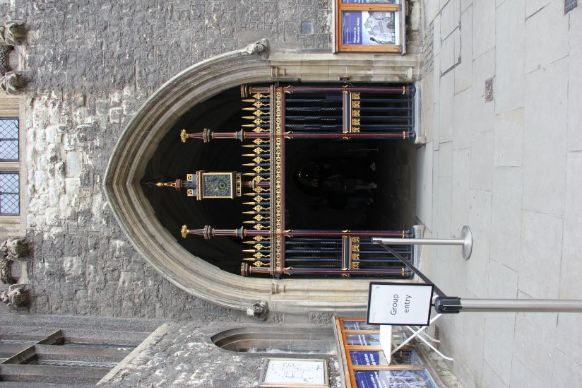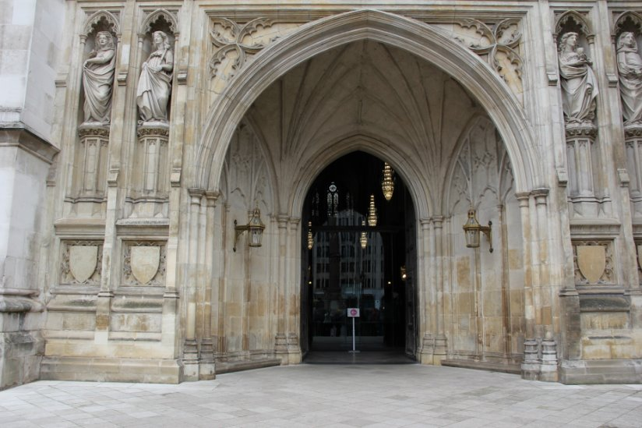When it is time to go, you will leave through either

The great west door

The cloisters/group entrance

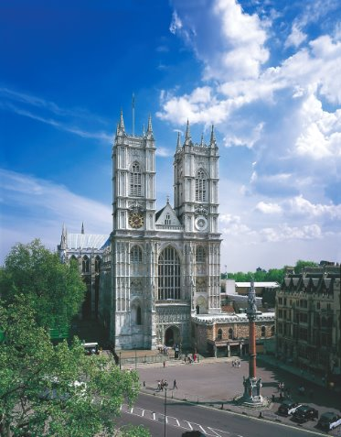 Thank you for visiting Westminster Abbey!