Your Visit to Westminster Abbey

Westminster Abbey is a big church in London.  
Everyone is welcome here.

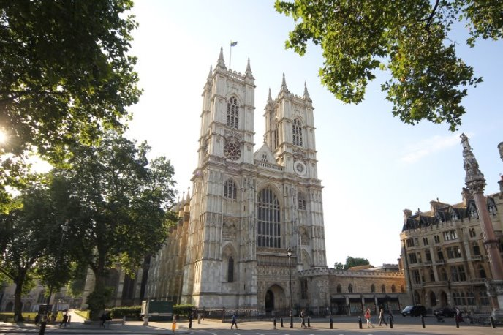

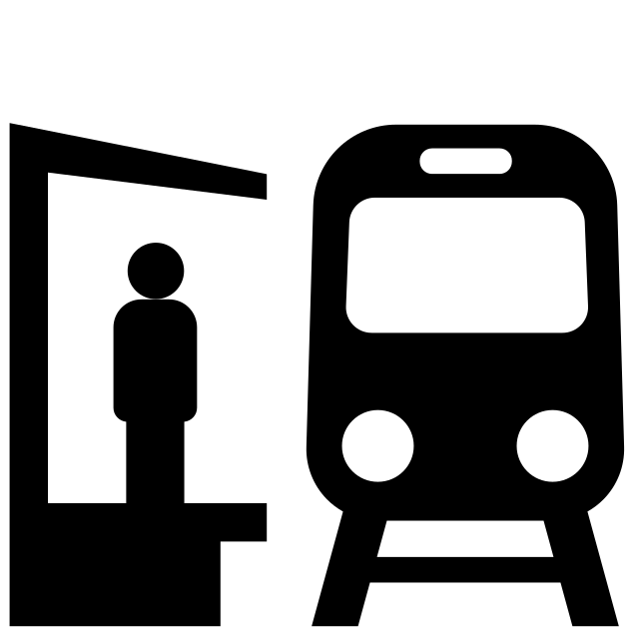You might travel to Westminster Abbey on a bus, a train, a coach or by walking.

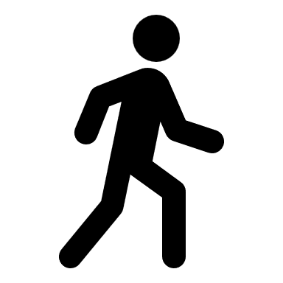

The area around Westminster Abbey can be very loud and busy with people and cars.

When you arrive you will walk around this barrier and through the 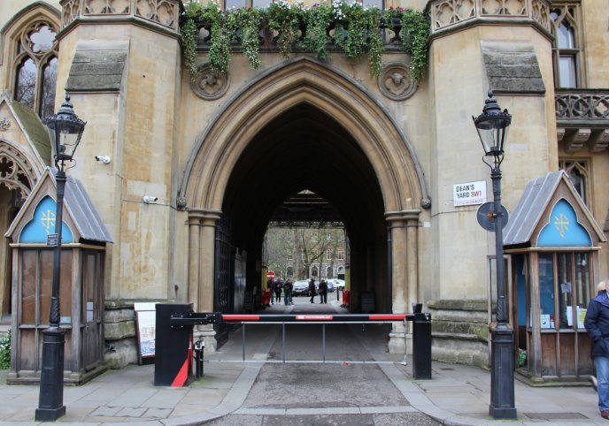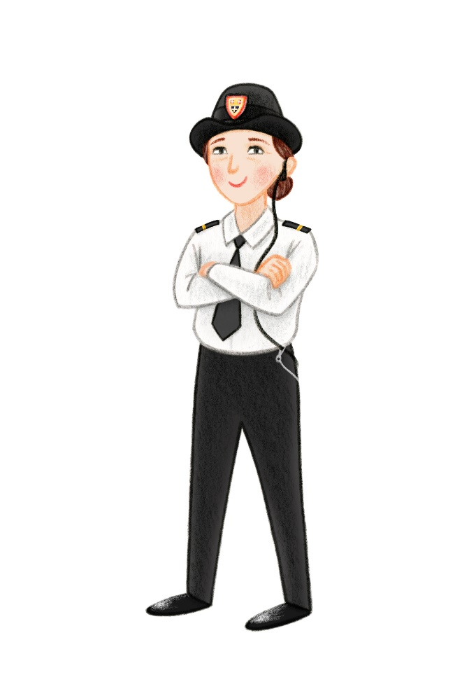archway.

You might meet one of our security team, who we call Beadles. They are very nice and can help you find your way.​

​You will then arrive at the Education Centre. ​  
You will enter through this entrance. These steps are steep but there is a handrail.

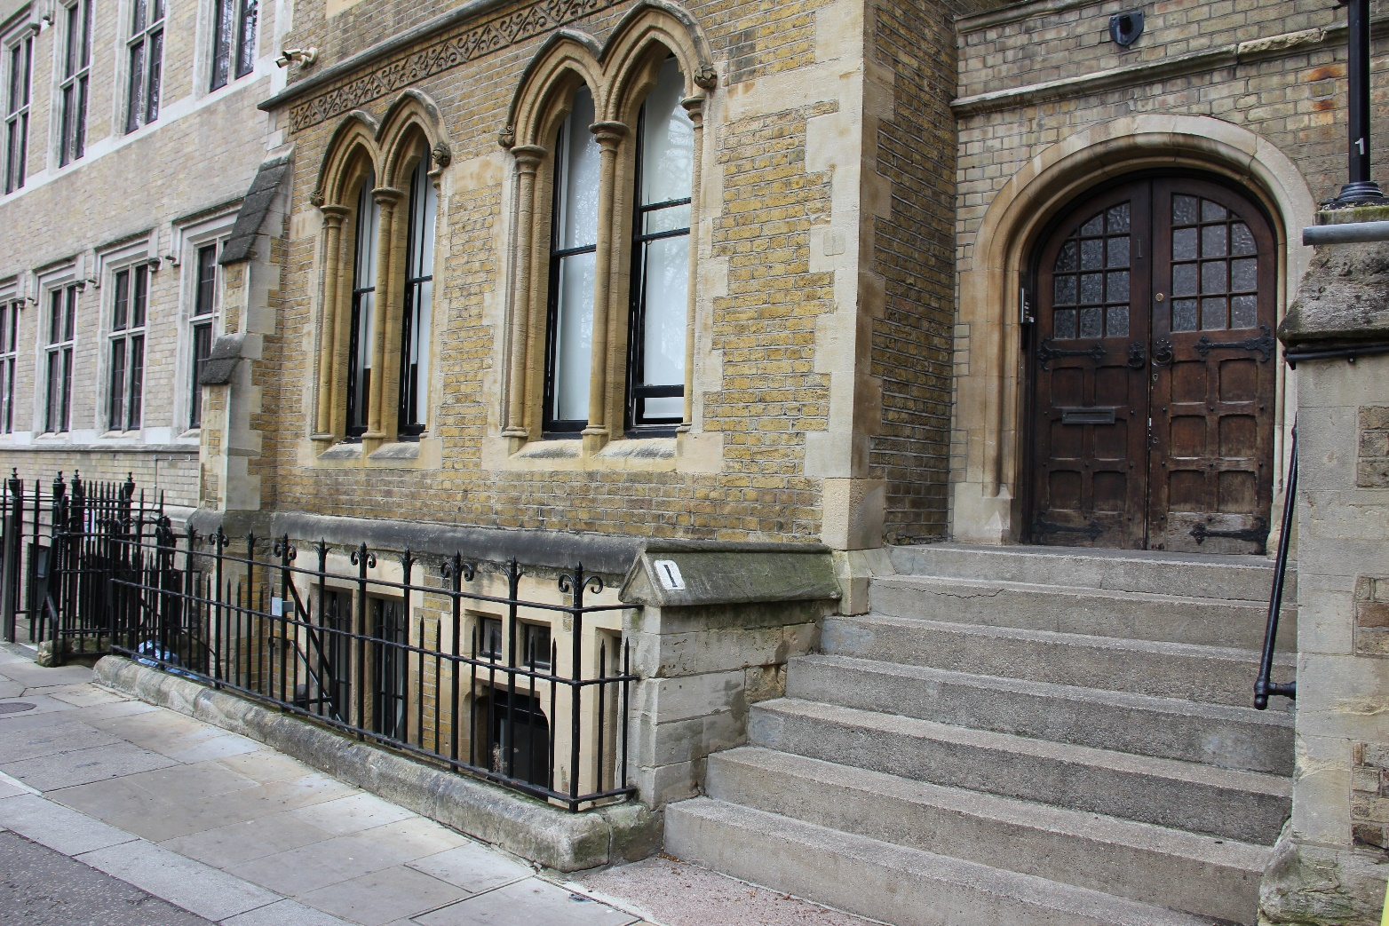

In the Education centre there will be a place for you to leave your 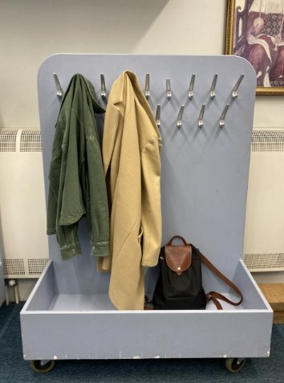bag and coat.

There are toilets you can use here, including an accessible toilet.

In the Education Centre you will meet a Learning Officer. They will welcome you and give you an introduction to the Abbey.

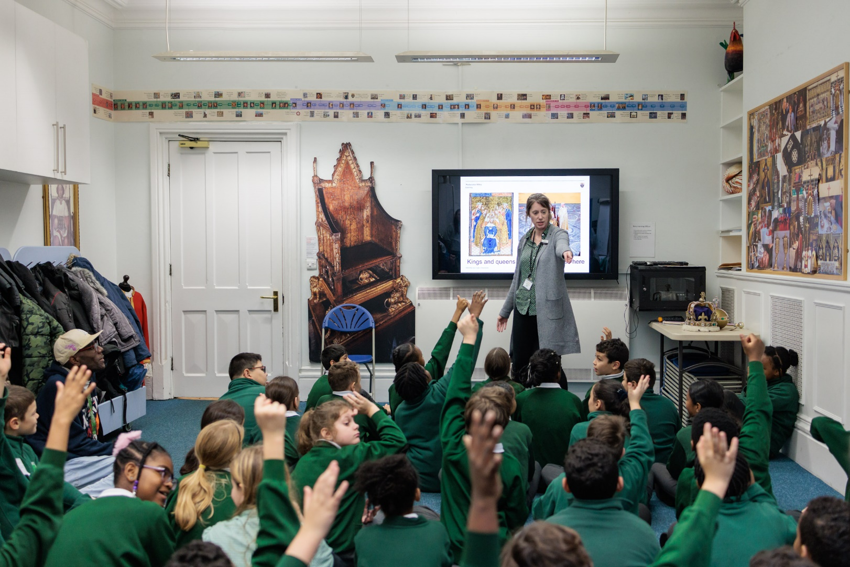

You might be split into groups before you start the tour. We will see the rest of the groups later when the tour is over.

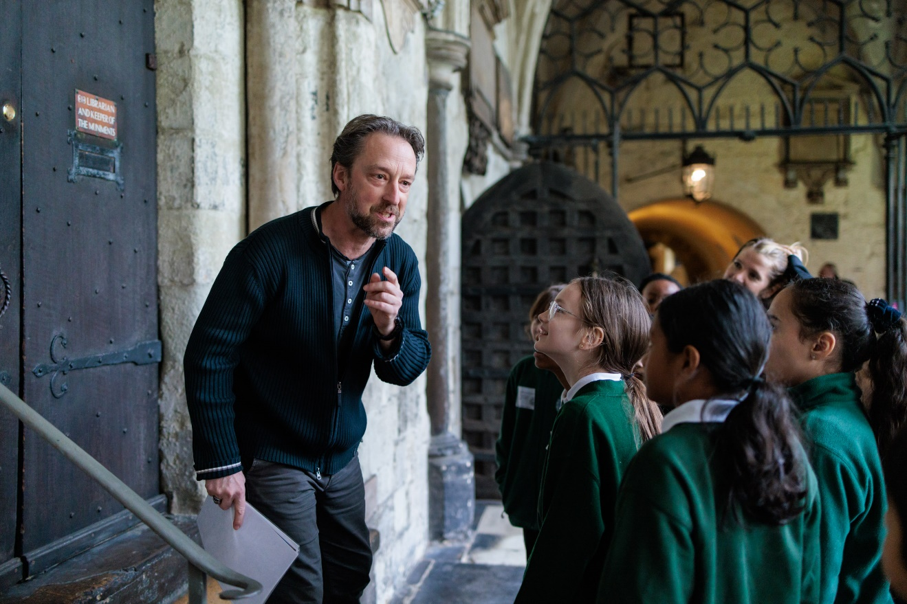

You will have a guide to show you around the Abbey; they can help you throughout your visit.

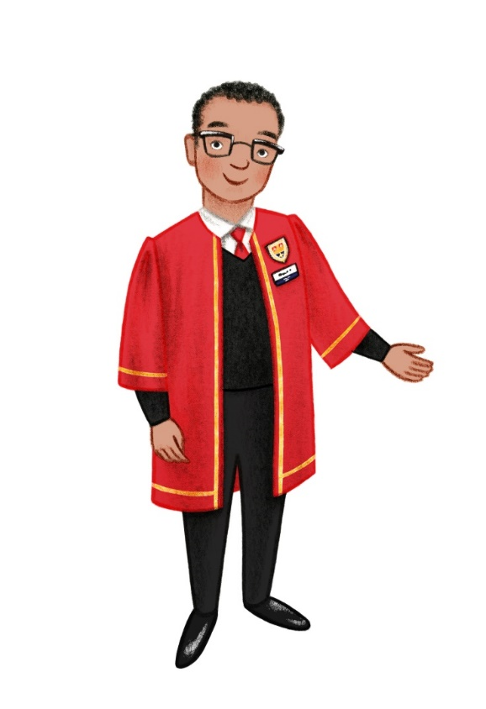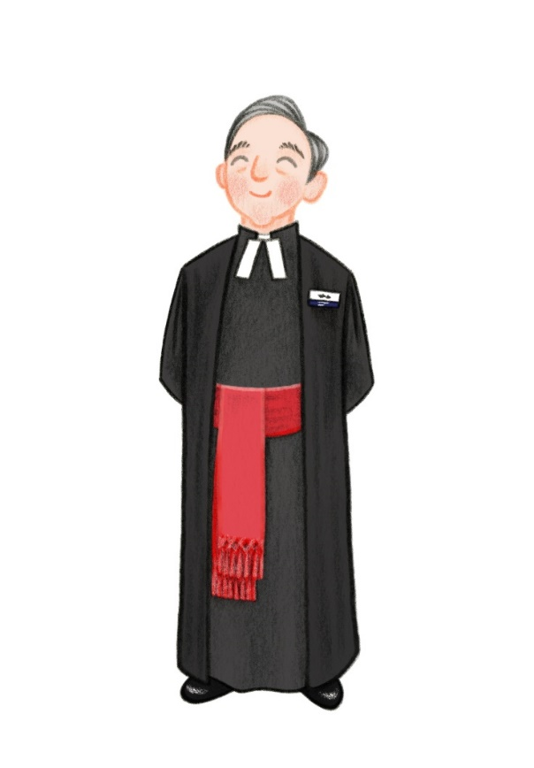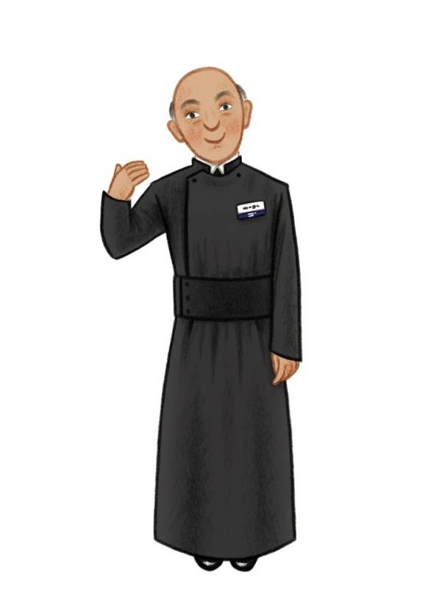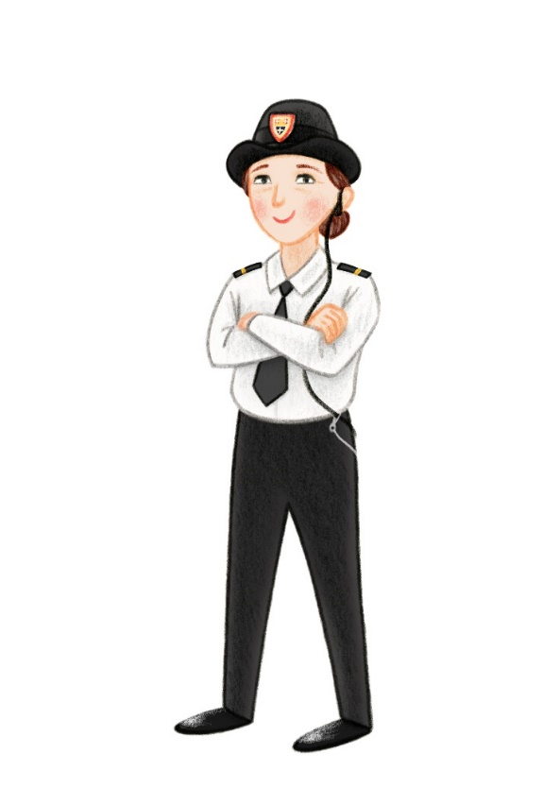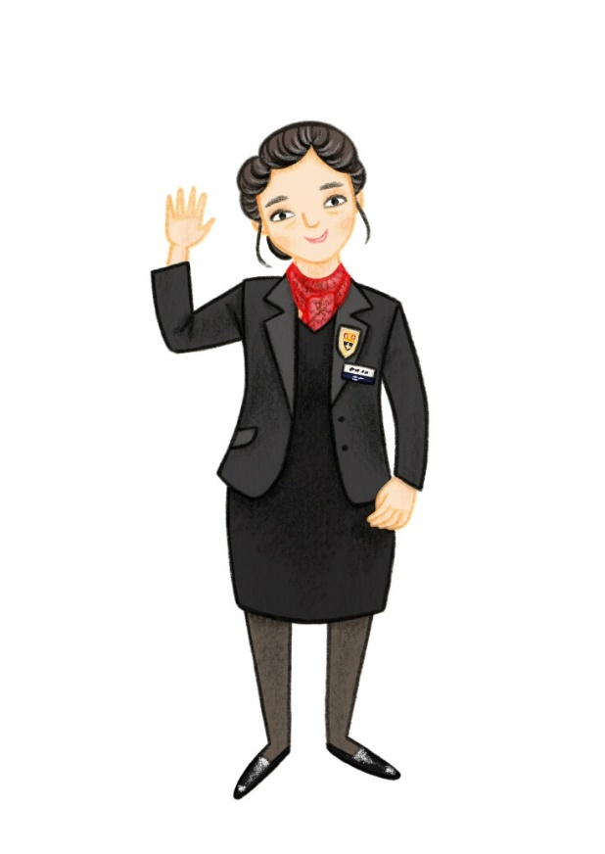Whilst inside the Abbey you might also meet:

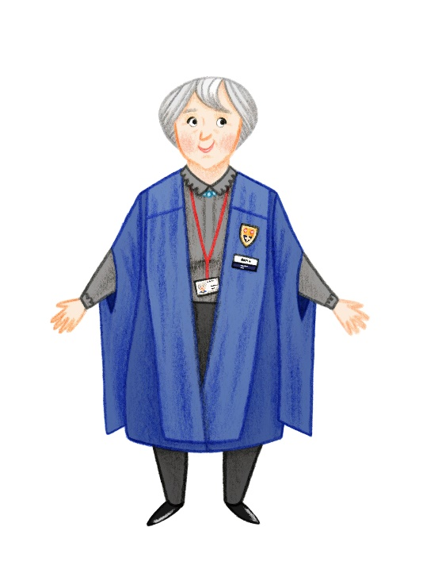

Beadles (Security)

Chaplains

Marshals

Volunteers

Vergers

Welcome Team

They are here to help you during your visit.

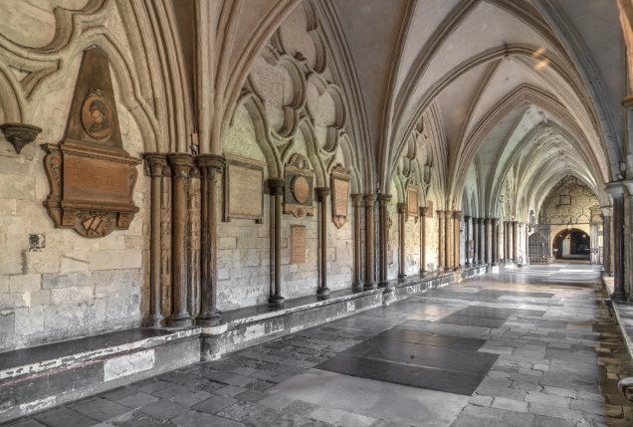 You might enter the Abbey through either

The great west door

The cloisters

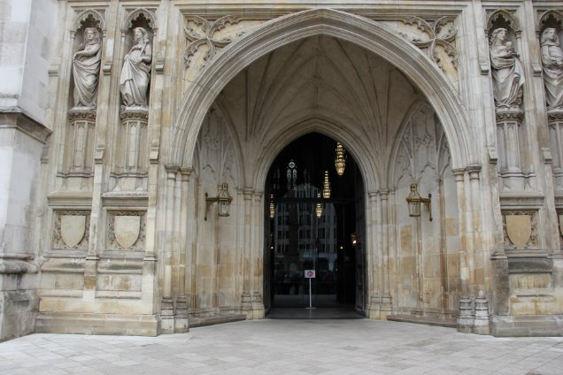Inside the Abbey it might be busy with lots of visitors and people 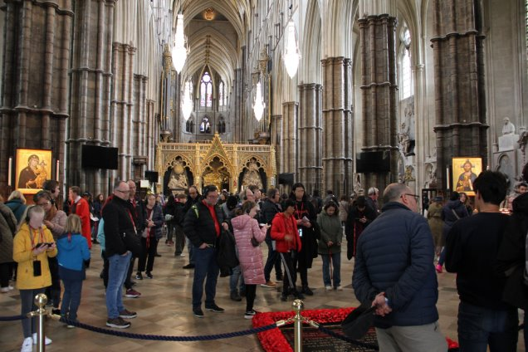who have come to pray.

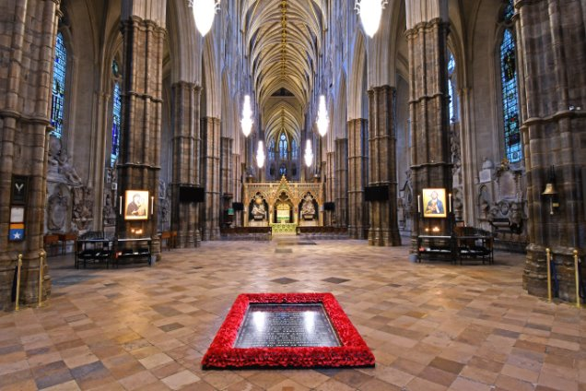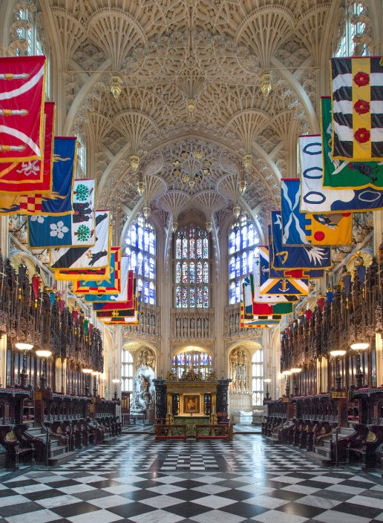

The Abbey has very high ceilings.

This can make sounds echo.

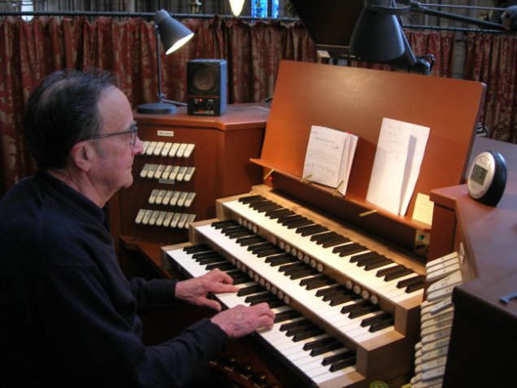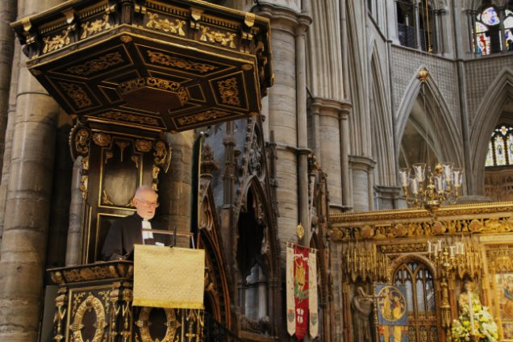Whilst at the Abbey you might hear:

People talking

People saying prayers

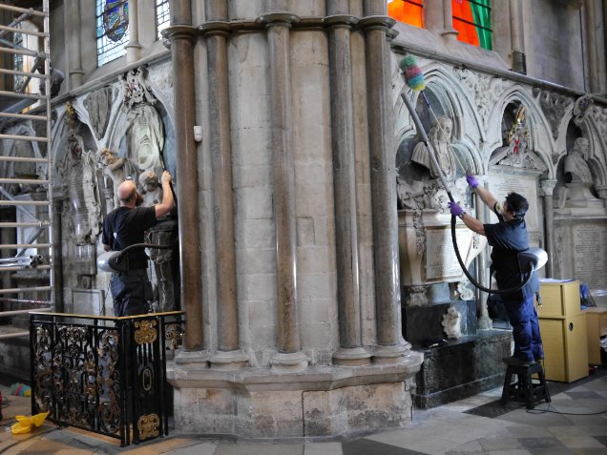Bells ringing

Music playing

People cleaning

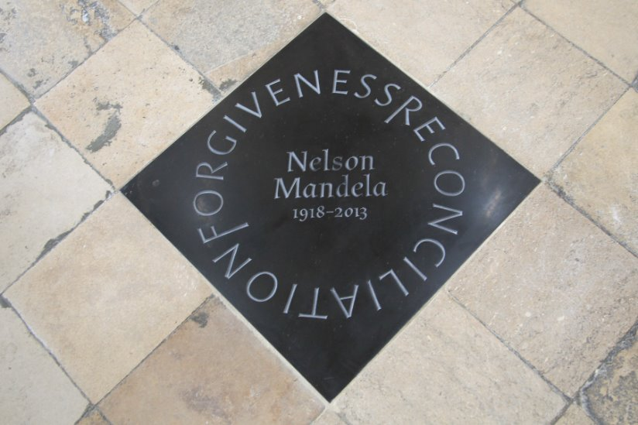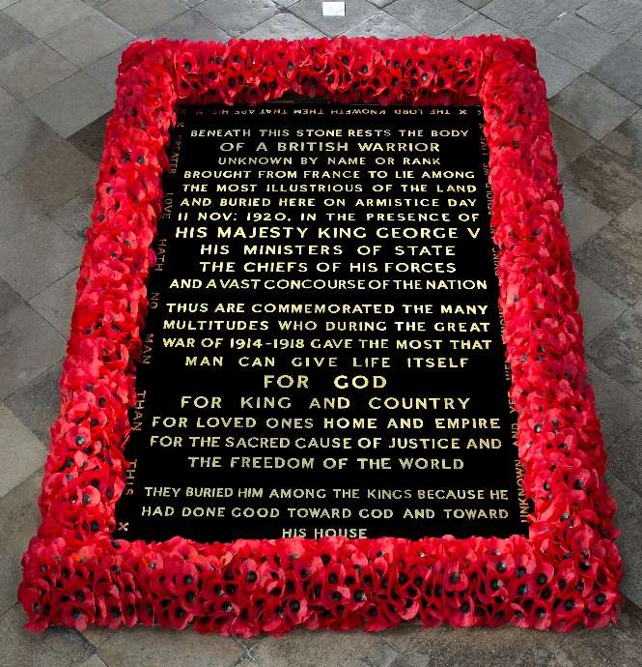 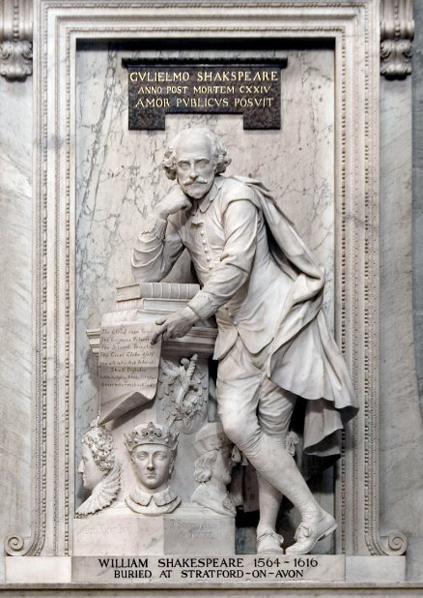Westminster Abbey is a place of burial and remembrance. There are graves, memorials and statues for people all over the Abbey.

You’re allowed to walk over the graves and memorials on the floor, except for the one surrounded by poppies.

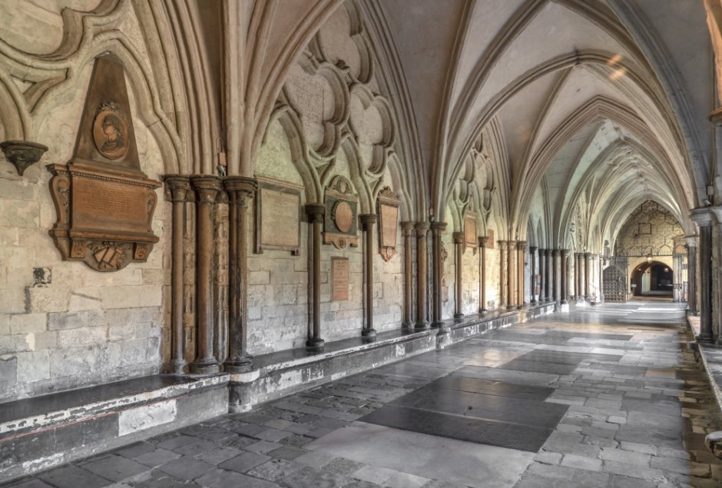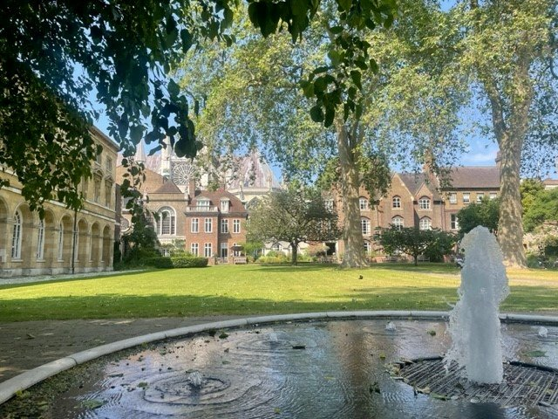If you need a time out or a quiet space during your visit, let your guide know and they can help you.

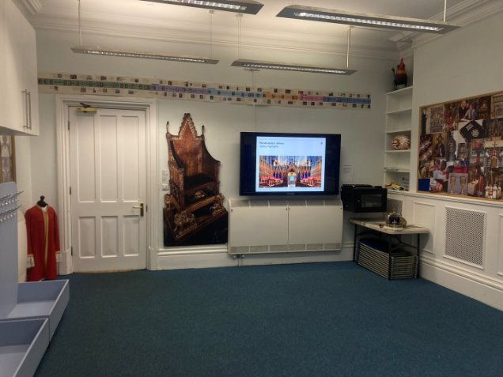At the end of your tour you will go back to the Education Centre to collect your bags and coats. You can also use the toilets.

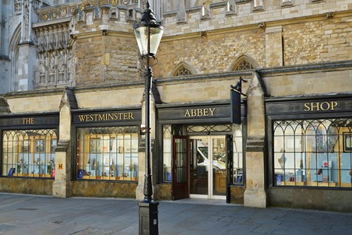At the end of your visit you might have lunch in the cloisters or the garden. Or you might visit the shop.

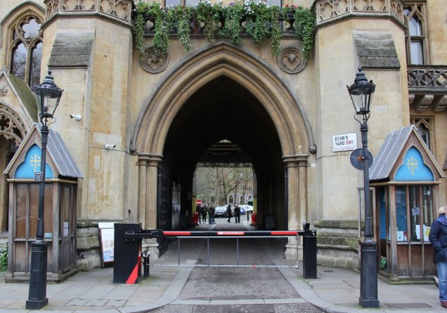  You will leave the way you arrived.

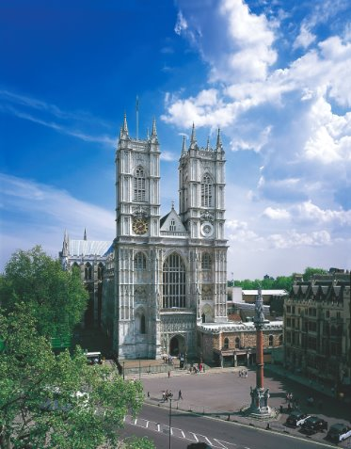 Thank you for visiting Westminster Abbey!